Lexie introduksjon

01.01.2013

Lexie Bernard - ny utvekslingsstudent fra Australia - velkommen!

I’m Lexie Bernard, a Rotary Exchange Student from Australia.
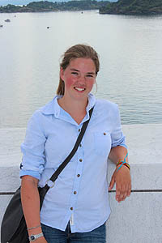
I am 15 years old and come from a small town called Willow Tree. It is in an agricultural area 4-5 hours North West of Sydney and has a population of 150 people.
I am sponsored by the Rotary Club of Quirindi.
I have been in Norway since January and I go to Kirkeparken in Moss.
I am really enjoying my time here in Norway.

You may follow my blog:
http://lexiesnorwegianexchange.blogspot.no/

