Hei!
Mitt navn er Helene Henriksen og jeg er 18 år gammel.
I juni 2013 kom jeg hjem etter et års opphold i Australia gjennom Rotary Youth Exchange. Der bodde jeg i staten NSW (New South Wales), i en liten by ved navn Armidale.
Jeg hadde et helt fantastisk år og kommer alltid til å huske min tid der.
Har dere lyst til å høre mer fra mitt opphold i Australia kan dere ta en kikk på rapportene mine fra oppholdet (link til mine ‘yeppers’).
Tusen takk Råde Rotaryklubb for at dere gav meg denne muligheten!
Les alle mine reisebrev (Yepper Reports), under!
Mvh
Helene

The Last Yepper...

I can’ believe the day has come, the day that I have to write my final YEPPER. It’s a sad day; I just don’t want this year to end. This whole experience has been out of this world!

Yepper report for April

One month. That’s the time I’ve got left in this beautiful country I like to call my second home. But I’m looking on the bright side and trying to enjoy my last weeks as much as I can. And I have to say I truly have enjoyed them during the past three weeks.
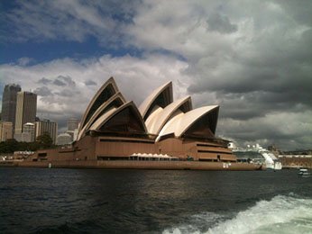

Yepper Report for March

March, you’ve been good to me! I’ve had the most amazing month in many ways. I went for a trip to Sydney, my parents came for a visit, and I went to Brisbane to see one of my favorite bands, The Lumineers. I almost haven’t had time to think about the fact that I’ve got under a 100 days left in this beautiful country, and I’ve decided I won’t be thinking about it either, just enjoy every moment I’ve got and make the most of it. Anyway, back to my month of adventures…

Yepper Report for February

Oh February, where did you go?! I guess it’s true what they say, time really does fly by when you’re having fun. This has been a wonderful month that has been filled with spending time with friends and ‘family’, and I’ve loved every minute of it!

Yepper Report for January

Here we go again, another month has gone by and that means another YEPPER has to be written. And gee do I have things to tell from this month, it’s been absolutely amazing!

Yepper Report for December

Another month has gone by, a month filled with celebrations, family gatherings and great fun.

Yepper Report for November

There is no doubt that November has been the best month so far! I’ve done so many things and they have all been amazingly fun.

Yepper Report for October

Almost four months have been spent Down Under already, this is crazy! I’m still loving every second of it, and this month has been awesome :D

Yepper Report for September

Another month has gone by, and I cannot believe that I’ve already spent almost three months of my life on the other side of the world. Time really does fly by!

Yepper Report for August

I’ve now been Down Under for precisely one month and 18 days, and honest to God, I’ve had the time of my life!
Totalt: 10

